**Forrester/SOA Software Webinar – APIs & the Path to Enterprise Digital Transformation**

* API changed the business dynamics – Case studies
  + Amazon kick started the API economy by transforming into an “Open Business” – one in which businesses chooses Amazon as partner instead of Amazon choosing its partners
    - This was a business strategy switch enabled by APIs
  + Different Business models enabled by APIs
    - SOA strategy extended to external consumers opening up channels for new revenues
* APIs forces thinking of ecosystems
  + The new “open business” differs from the traditional business in that it gears up for integration upfront
  + Integration over here means collaboration

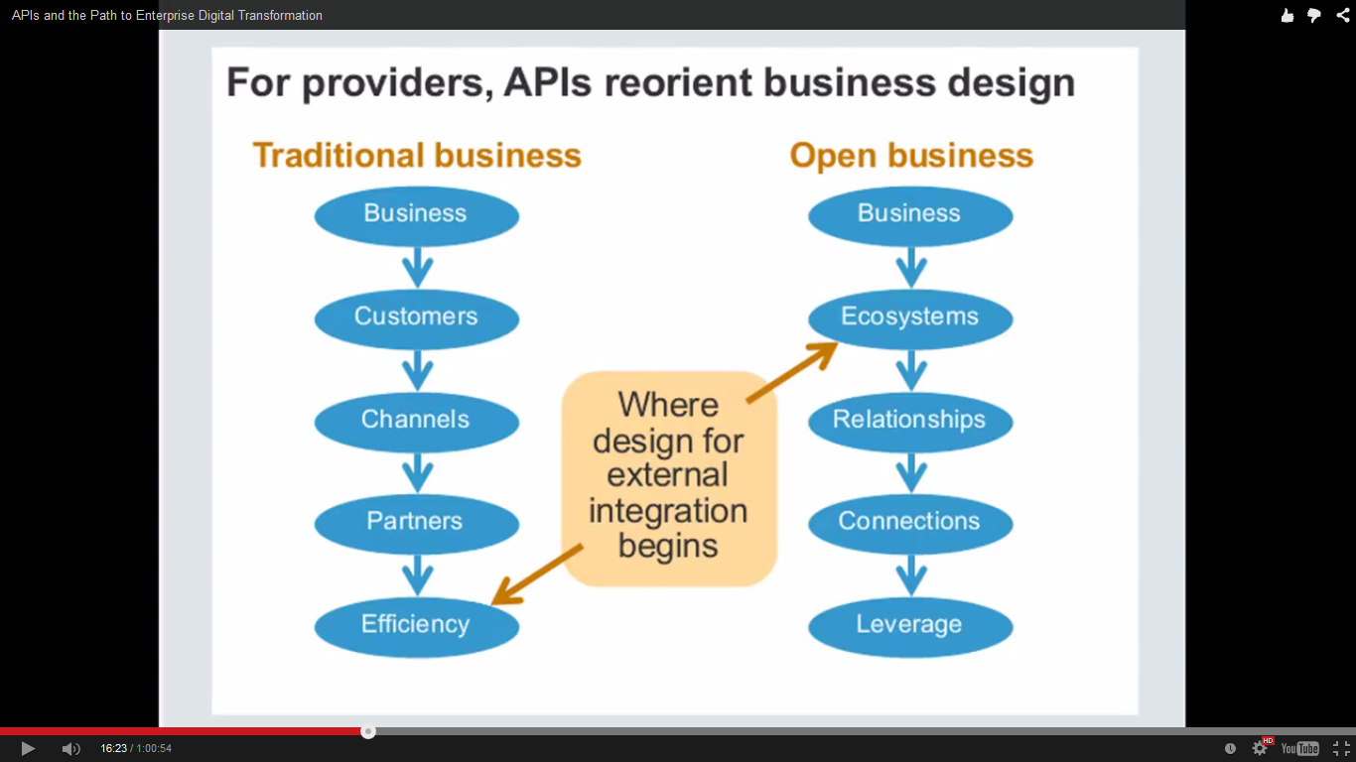

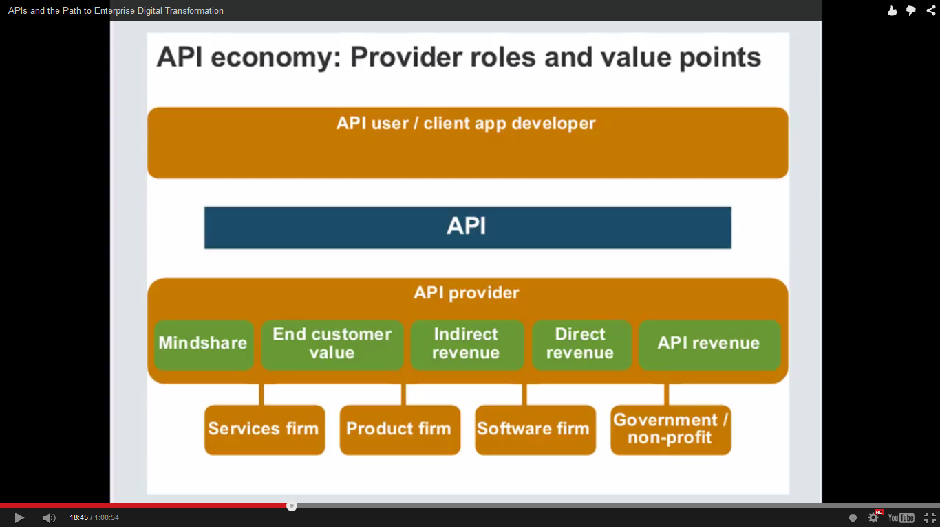

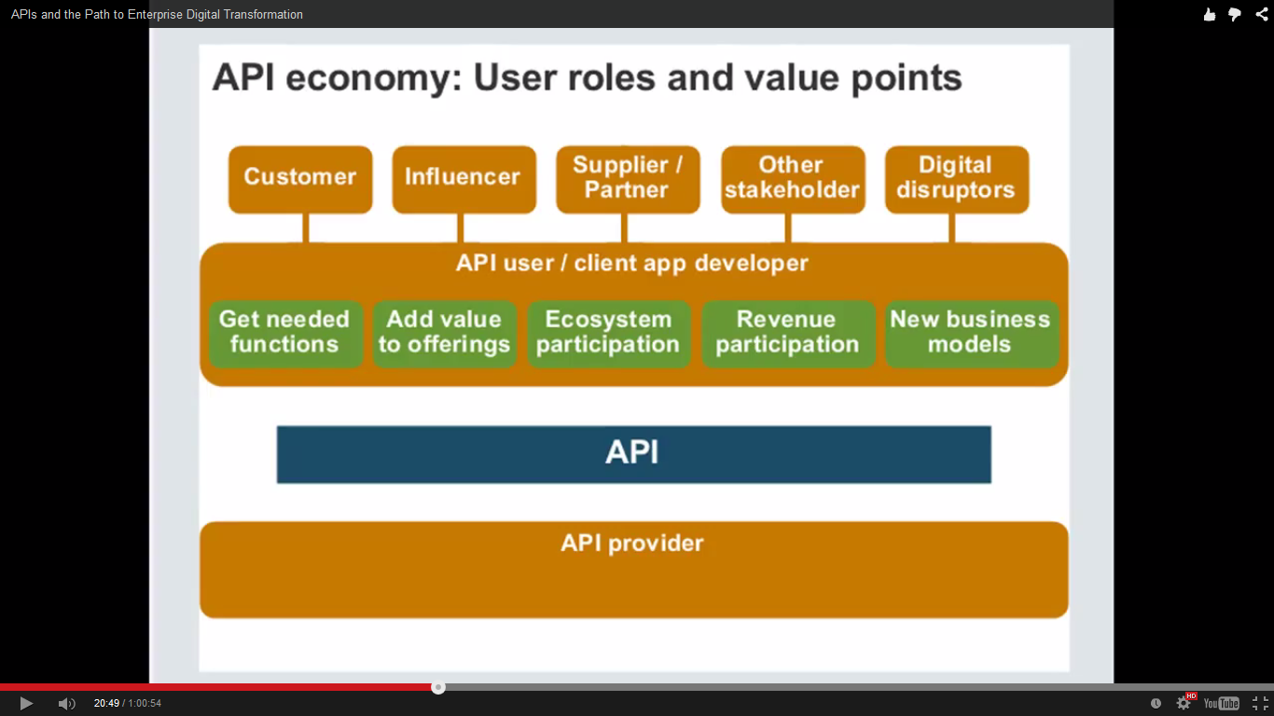

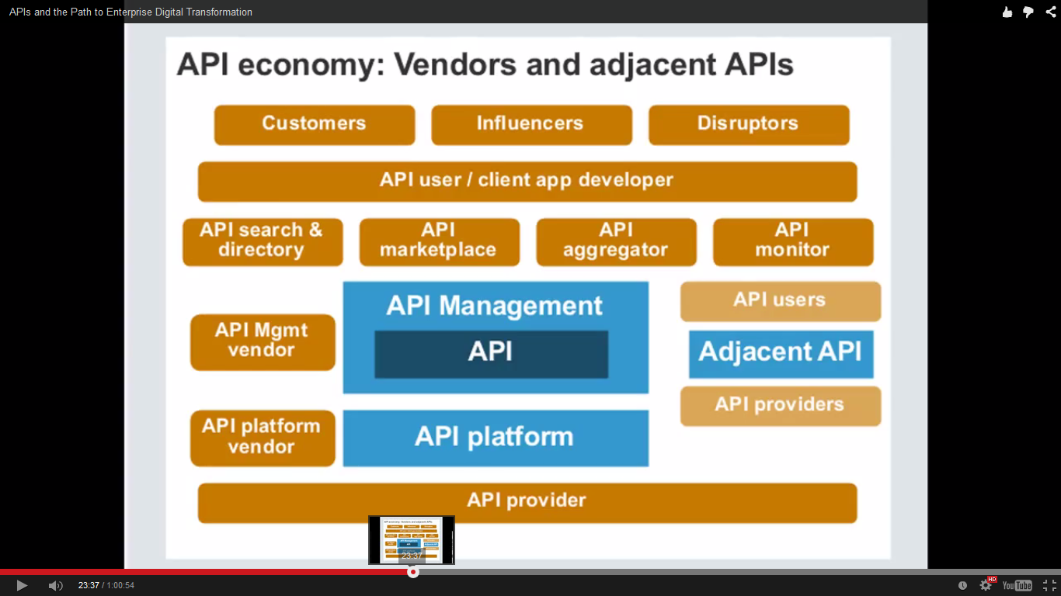

* Adjacent APIs
  + Related APIs which offer value when packaged together
  + Can be a major factor in API success stories – hence importance of collaboration

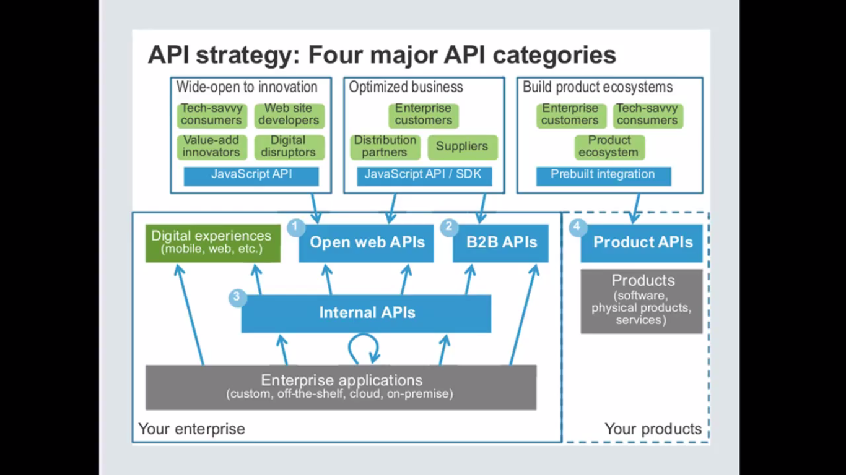

* Product APIs
  + APIs to manage actual products, e.g. software, physical products, etc.
  + E.g. APIs to manage your hotel room like room temperature, tv channel, etc.

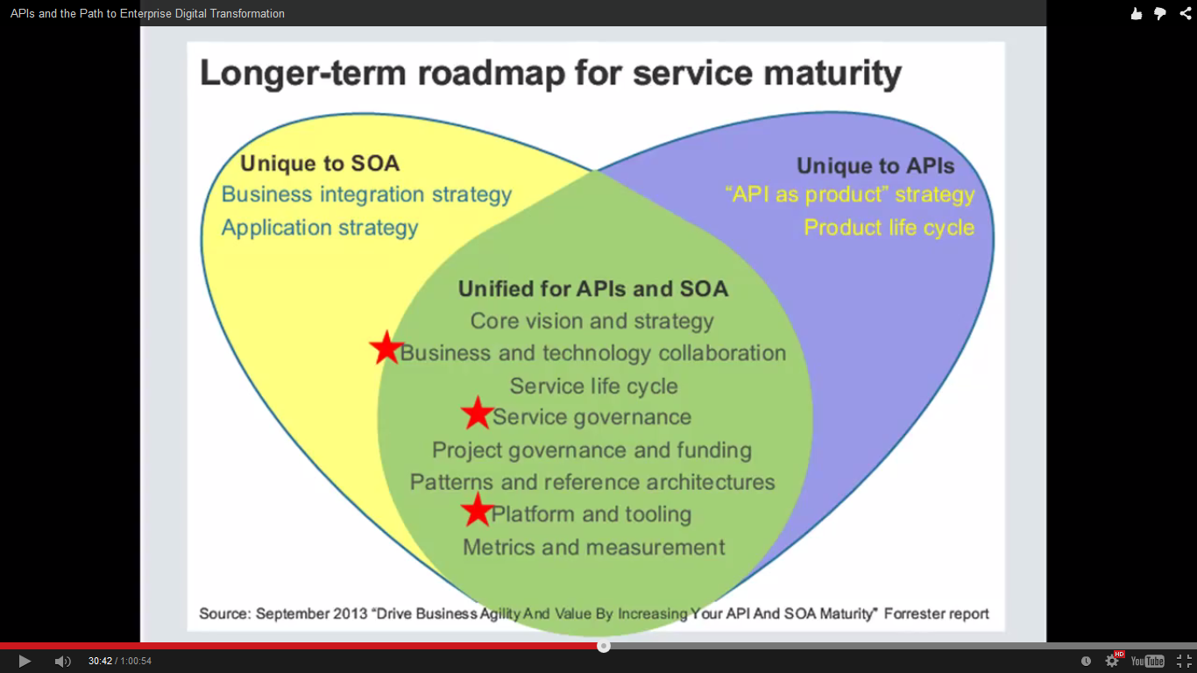

* API Design Strategy
  + How are you going to design your APIs?
    - Functional design
      * Most important when it comes to adoption success
    - Technical design
      * How do I handle QoS?
  + API Categories
  + API Types
    - Resource oriented or Action oriented
      * REST does not address Action oriented APIs
    - UI support/streaming APIs
      * “API First” strategy has pros and cons
        + Can end up in User Experience tied APIs and hence fail from adoption perspective
  + Interface Technical Design
  + Community concerns

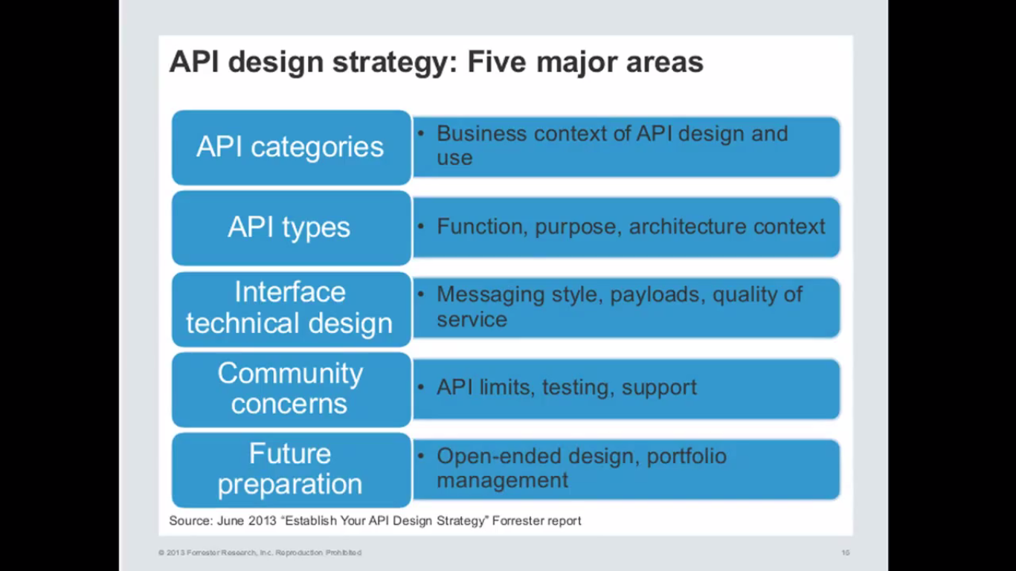

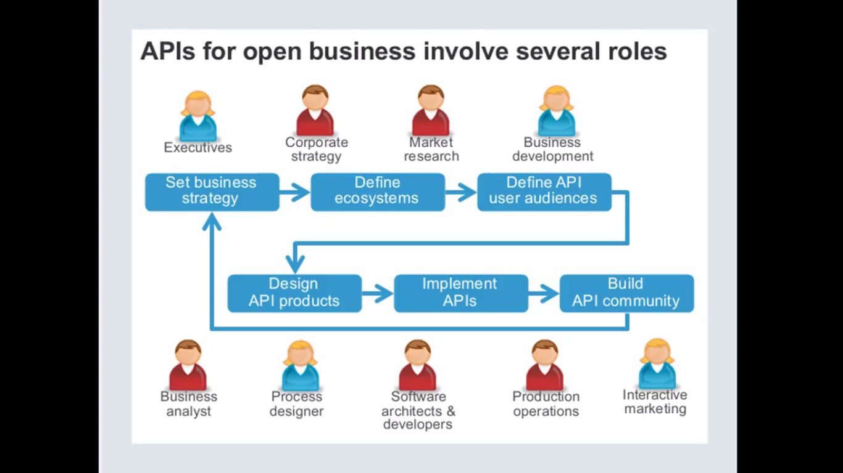

* It is important to infuse business strategy and competencies into API design

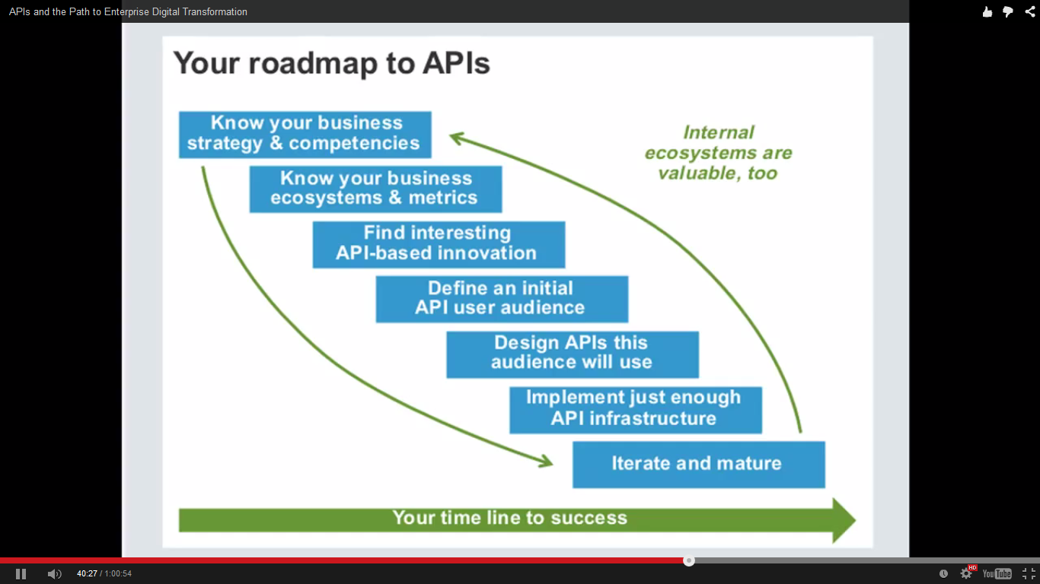

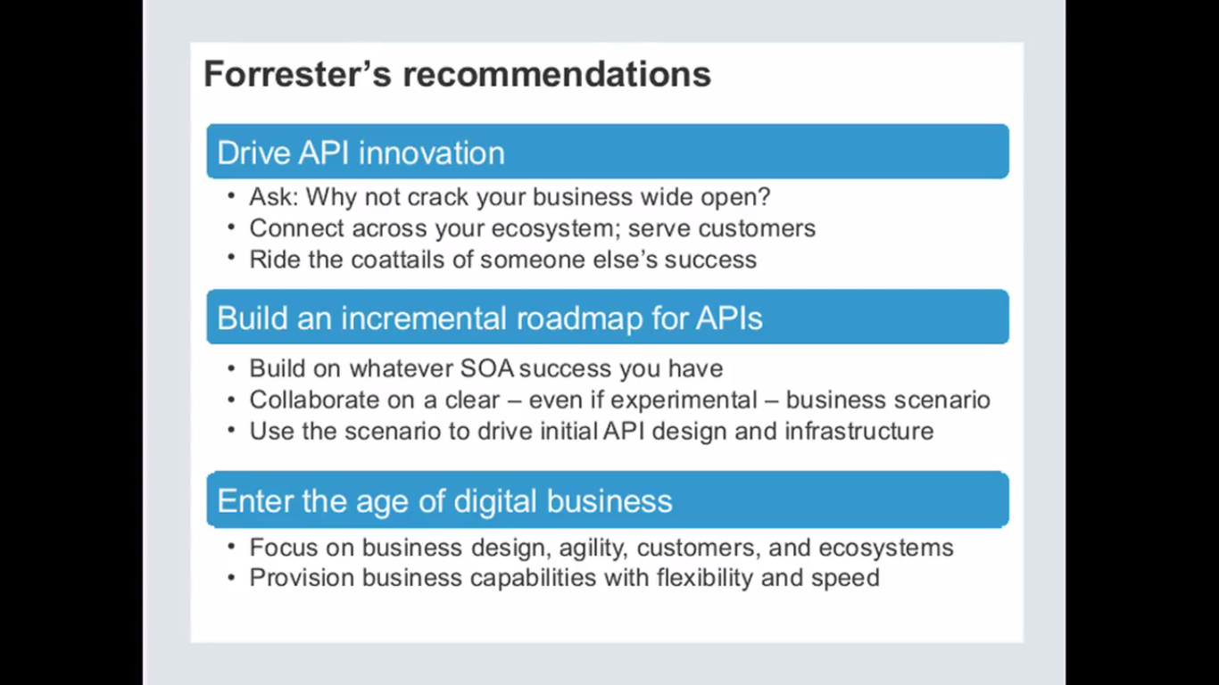

* Path to digital transformation (SOA Software)

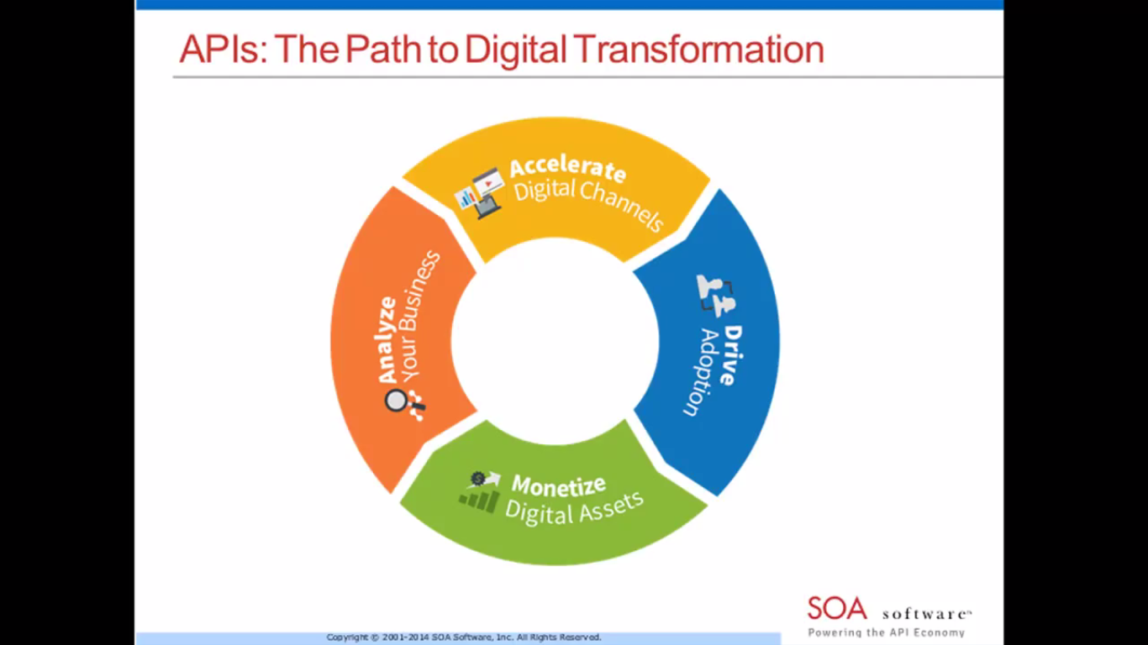

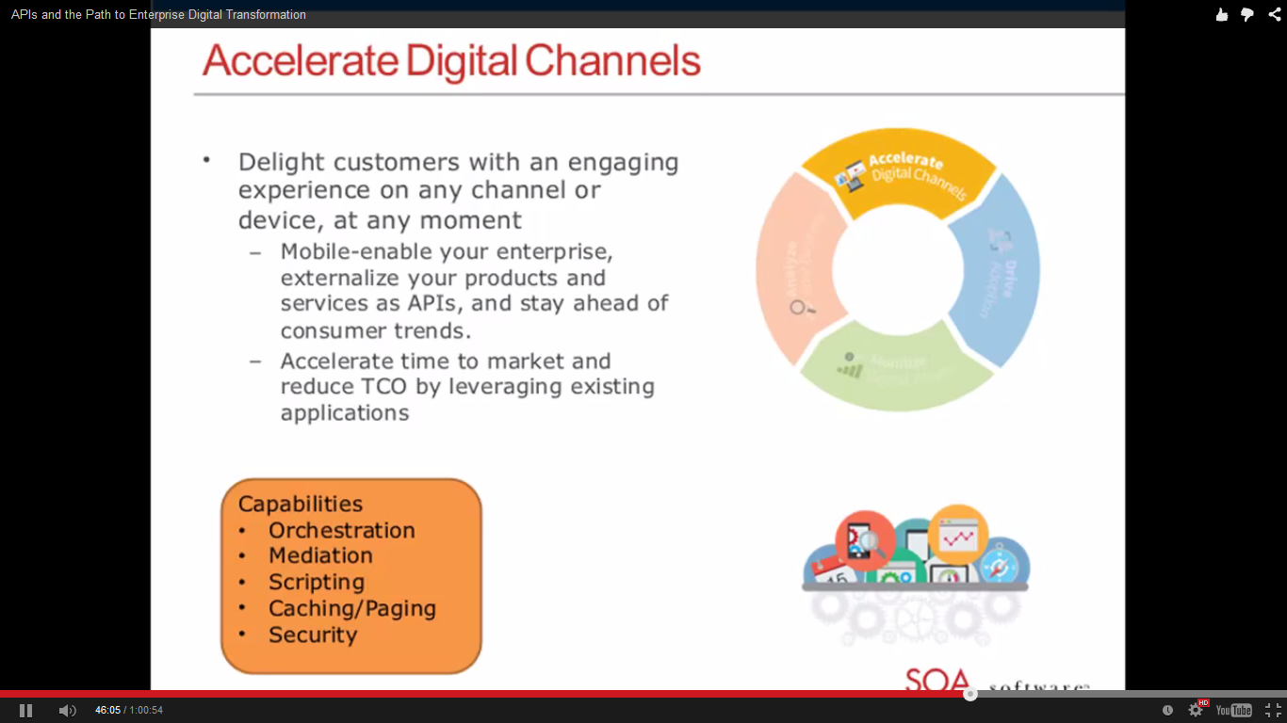

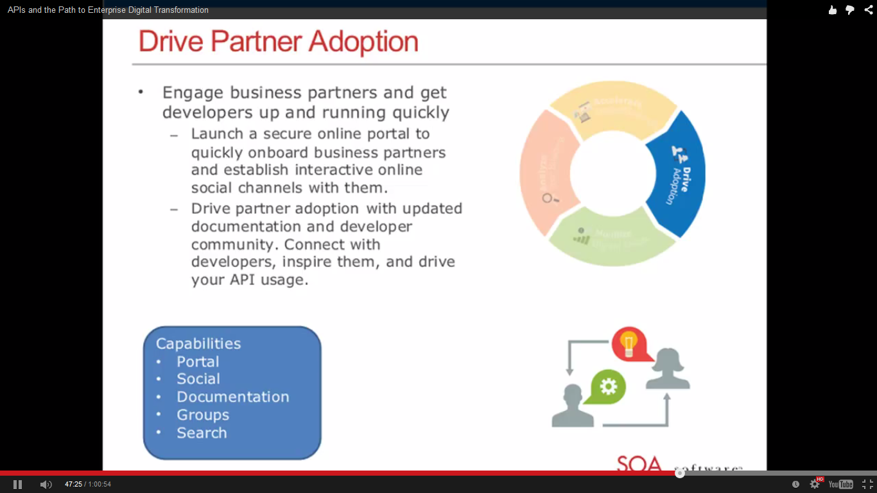

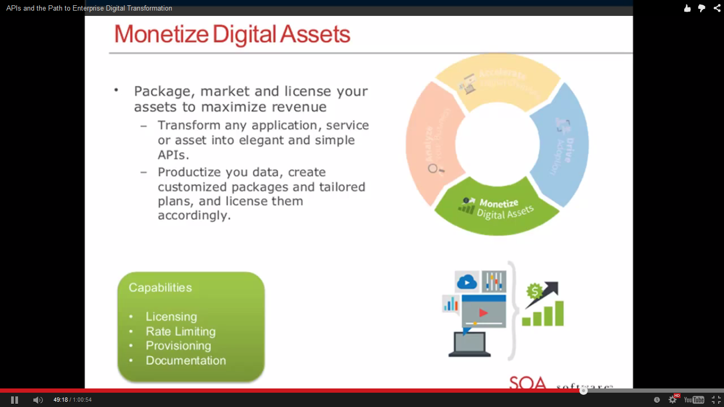

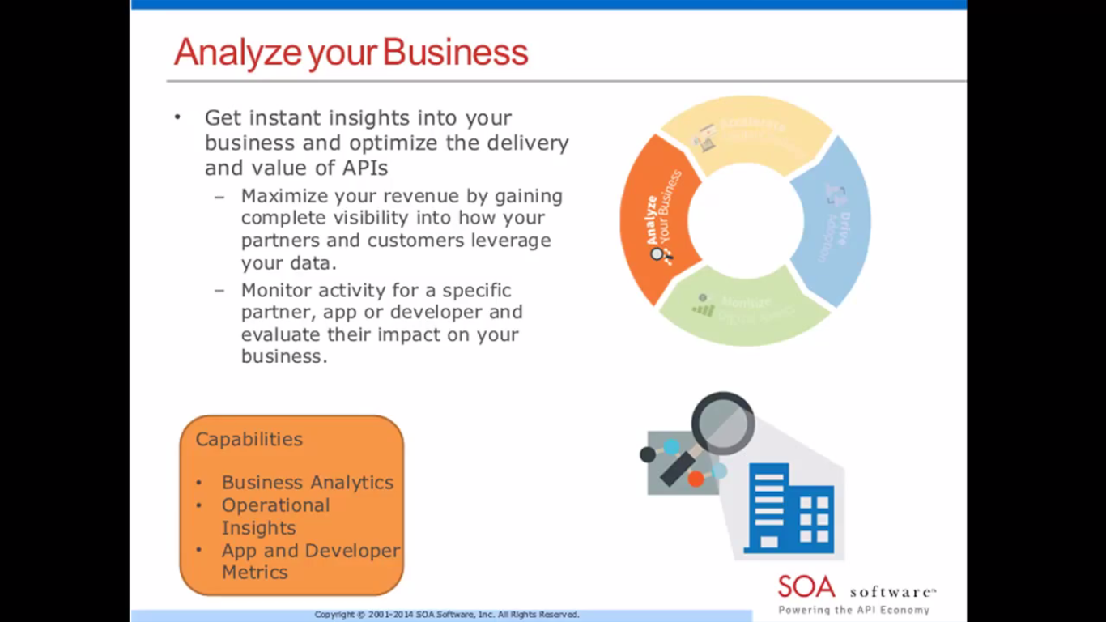

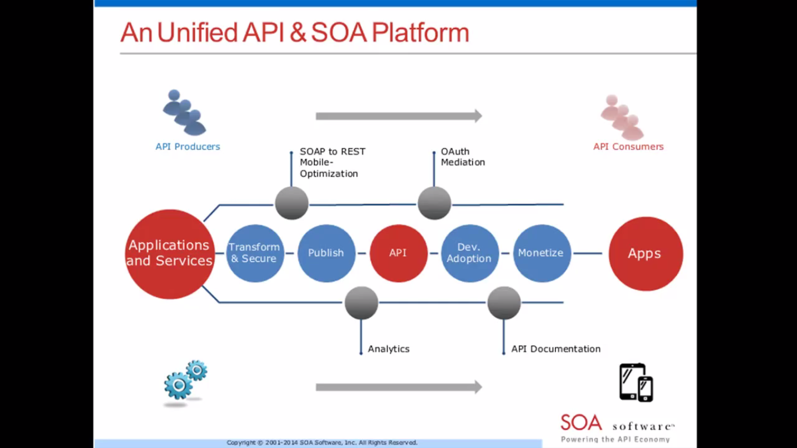

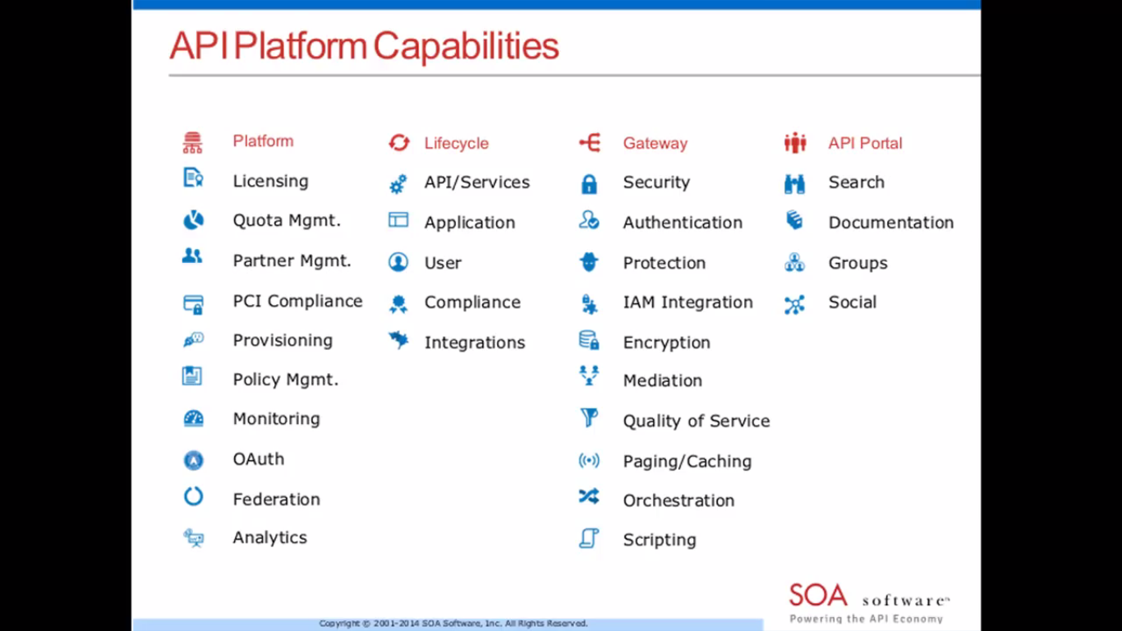

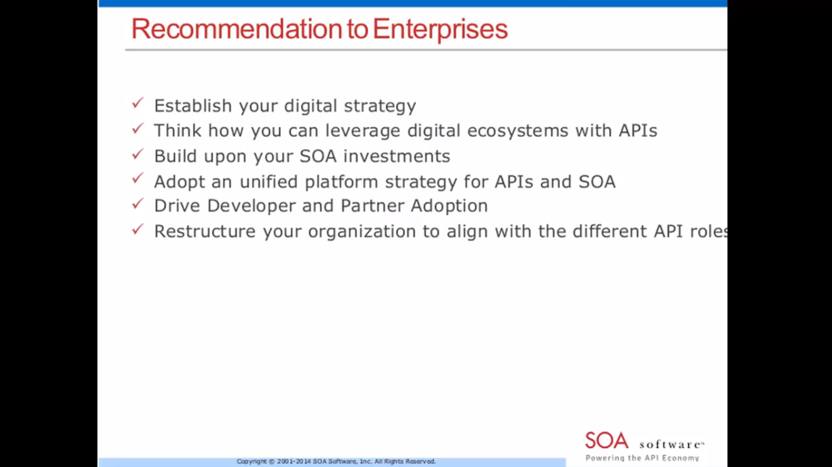

Tomorrow

**New Webinar – Akana – Forrester**

June 17, 2015

